

Programme | : | M.Tech Int Software Engineering | Semester | : | Fall 2026-2027
Course | : | Database Systems Lab | Code | : | IASWE206
Faculty | : | Dr. M. Premalatha | Slot | : | L31+L32

Ex. No. 2
Date: 13-07-2026
SQL Basics – DDL and DML Commands

Note:
LMS Submission Format [Word File]
Regno, name
Course code, course title
Slot
Faculty Name
Question
SQL Query – Text Format (Copy Paste)
Screenshot

Ex:
Question:
create a student table with attributes regno, name, mobno and dob with appropriate datatypes and sizes

Query:
SQL> create table student_mp(regno varchar(4), sname char(10), mobno number(10), dob date);
Table created.

Screenshot:

SQL> desc student_mp
Name Null? Type
----------------------------------------- -------- ------------
REGNO VARCHAR2(4)
SNAME CHAR(10)
MOBNO NUMBER(10)
DOB DATE
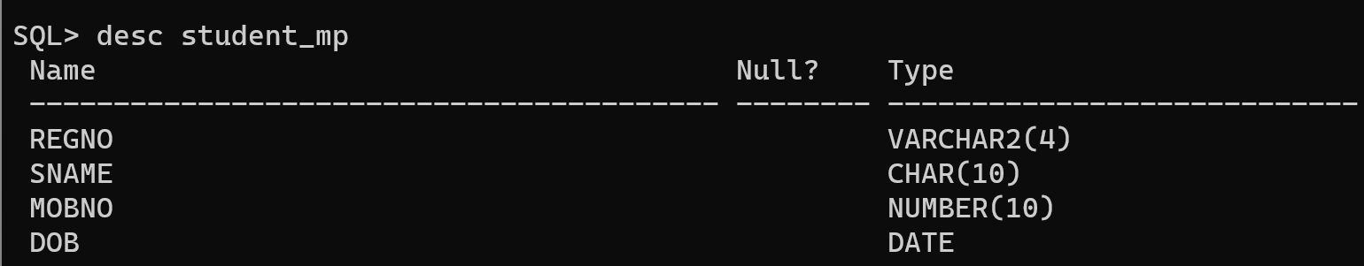

Consider the following enterprises for which the specified type of relations can be created. Choose any one from the list or any other enterprise of your choice for Querying DDL and DML commands
Note: Each specification in the description is to be considered as each object.

S.No | Enterprise | Description
1 | Hospital Management System | Manages patients, doctors, appointments, treatments, billing, and pharmacy.
2 | University Management System | Handles students, faculty, courses, enrollment, examinations, and attendance.
3 | Banking System | Maintains customers, accounts, loans, transactions, branches, and employees.
4 | Library Management System | Manages books, members, borrowing, returns, fines, and reservations.
5 | Hotel Management System | Handles rooms, guests, reservations, check-in/check-out, and billing.
6 | Airline Reservation System | Manages flights, passengers, tickets, schedules, airports, and crew.
7 | E-Commerce System | Handles customers, products, orders, payments, inventory, and shipping.
8 | Retail Store Management System | Manages products, suppliers, sales, inventory, employees, and customers.
9 | Online Food Delivery System | Handles restaurants, menus, customers, orders, delivery partners, and payments.
10 | Human Resource Management System (HRMS) | Manages employees, departments, payroll, attendance, leave, and recruitment.

Part A: DDL Commands

- Create any one table of your choice with 4 attributes. Make sure you have a char, number of integer and floating point, and date datatypes.
- Add an attribute to the relation and describe the structure of the table.
- Change the data type of any of the attributes in a relation and describe the structure of the table.
- Change the size of any one attribute and describe the structure of the table.
- Rename any one attribute in the relation and describe the structure of the table.
- Insert 7 records into the relation. Commit the records.
- Display the contents of the relation
- Copy the contents of table to another duplicate table
- Delete any one domain from the relation, describe the structure of the table and display the contents of the table
- Rename the table name
- Delete the contents of duplicate relation, describe the structure and display the contents of the table
- Delete the structure of the duplicate relation, describe the structure and display the contents of the table

Part B: DML Commands

Note:
a) Write the english query as question for each of the following. Ex: Apply each type of comparative operators and display the records
English Query:
- List the student details who have scored >9 CGPA
- List the student details whose data of birth is 12-aug-2007
- List the student details who doesn’t belong to MTech programme
- List the student details who have registered for python and java
- List the student details who have registered for either java or python
- List the student details who have registered for python but not jave
b) No result should throw “no rows selected”. Read the questions properly and insert the records accordingly.
- List the records of the relation.
- Apply each type of comparative operators and display the records
- List a record by specifying a condition applied for date
- Apply each type of logical operators and display the records
- Sort the table in descending order
- Sort the table in ascending order
- Apply ascending order for an attribute and descending order for another attribute
- Use all possible _ and % string handling functions
- Apply range and display the records
- Select a record which has a null value

